EXPERIMENT-1 INTRODUCTION TO DISCRETE EVENT SIMULATION AND DISCRETE EVENT TOOLS
1. SYSTEM
A system is a collection of entity and objects that act and interact together towards some logical end.
1.1 Model of a System
A model is defined as a representation of a system for the purpose of studying the system. Many times one can't experiment with a real system such as a bank, or a highway system. One has to expriment with a model of the real system. A model is often not exactly the same as the real system it presents. Rather, it includes a few (or majority of) key aspects of the real system. It is an abstraction of the real system.
1.2 Components of a System
An entity is an object of interest in the system. E.g. customers in a bank.
An attribute is a property of an entity. E.g. the checking account balance of the customer.
An activity represents a time period of specified length. Here the time period is emphasized because often the simulation involves time. E.g. deposit money into the checking account at a specified date and time.
The state of a system is defined to be that collection of variables necessary to describe the system at any time, relative to the objectives of the study. E.g. number of busy tellers, number of customers waiting in line.
An event is defined as an instantaneous occurrence that may change the state of the system. E.g. customer arrival, addition of a ne teller, customer departure.

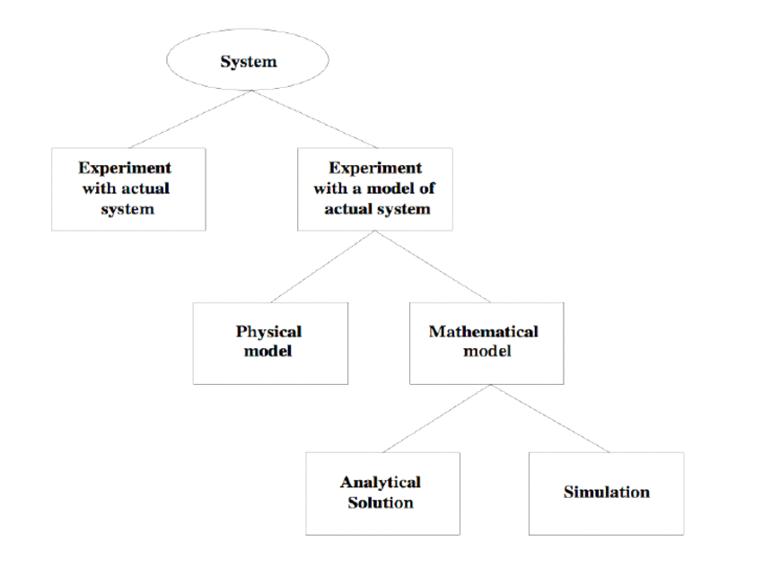

2. DISCRETE vs CONTINUOUS SYSTEM
A discrete system is one in which the state variable(s) change only at a discrete set of points in time. E.g. customers arrive at 3:15, 3:23, 4:01, etc.
A continuous system is one in which the state variable(s) change continuously over time. E.g. the amount of water flow over a dam.

3. SIMULATION
A simulation is the imitation of the operation of a real-world process or system over time.
Network simulation is a technique whereby a software program replicates the behavior of a real network. This is achieved by calculating the interactions between the different network entities such as routers, switches, nodes, access points, links, etc.
Steps include
Generating an artificial history of a system
Observing the behavior of that artificial history
Drawing inferences concerning the operating characteristics of the real system

3.1 Simulation tools
A. GNS3 – Graphical Network System 3
Graphical Network System 3 (GNS 3) is Network Simulation/Emulation Tool & Software, and it is a kind of Virtual Network in a Suitcase. GNS3 can simulate the complex network and scenarios and supports the combination of virtual and real network devices. GNS3 is one of the best network simulation tools to build, design, configure, and test your network scenarios in a completely risk-free virtual environment. GNS3 network simulation tool is available for Windows, Linux & Mac.
B. Cisco Packet Tracer
Cisco Packet Tracer is a dominant network simulation tool built by Cisco Systems. You can make a simple or complex network inside the Packet tracer to create, plan, configure, and test your network scenarios in a completely virtual ecosystem. This Network Simulation tool allows users to create network topologies and imitate those in modern computer networks. Packet Tracer is one of the most famous Networks Simulation software among networking aspirants and beginners. It is used actively during the Cisco CCNA Certification Training.
C. Putty
PUTTY is a completely free and open-source terminal emulator, serial console, and network file transfer application. It supports several network protocols, including SCP, SSH, Telnet, login, and raw socket connection.
D. Wireshark: Wireshark is a software tool used to monitor the network traffic through a network interface. It is the most widely used network monitoring tool today. Wireshark is loved equally by system administrators, network engineers, network enthusiasts, network security professionals and black hat hackers.
The extent of its popularity is such, that experience with Wireshark is considered as a valuable/essential trait in a computer networking-related professional.

4. SYSTEM ORDER
A deterministic model is a model where:
1 - the material properties are well known, i.e. deterministic. none of them is random
2 - The applied load are also deterministic
A Stochastic model has on the other hand:
1 - random properties, e.g. the Young's modulus is a random variable with uniform distribution [E1, E2]; or normal distribution (of a given mean or standard deviation)
2 - The applied load is random variable, e.g. Wind Load, earthquake (vibration of random amplitude and displacement)

6. MODEL TAXONOMY

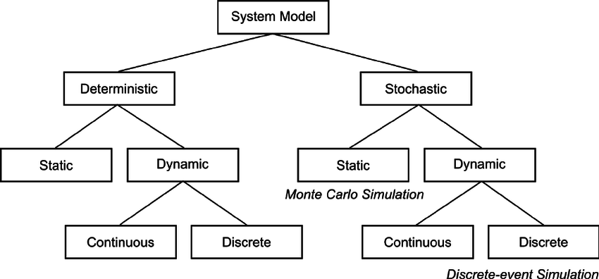

EXPERIMENT 2: Difference between NS2 and NS3.
NS3: It is a discrete event network simulator for Internet. NS3 helps to create various virtual nodes (i.e., computers in real life) and with the help of various Helper classes it allows us to install devices, internet stacks, application, etc to our nodes.
Features of NS3:
Ns3 gives us special features which can be used for real life integrations. Some of these features are:
1.Tracing of the nodes:
NS3 allows us to trace the routes of the nodes which helps us to know how much data is send or received. Trace files are generated to monitor these activities.
2.NetAnim:
It stands for Network Animator.It is an animated version of how network will look in real and how data will be transferred from one node to other.
3.Pcap file:
NS3 helps to generate pcap file which can be used to get all information of the packets (e.g., Sequence number, Source IP, destination IP, etc). These pcaps can be seen using a software tool known as wireshark.
4.gnuPlot:
GnuPlot is used to plot graphs from the data which we get from trace file of NS3. Gnuplot gives more accurate graph compare to other graph making tools and also it is less complex than other tools.

NS2 | NS3
Application level Difference between NS2 and NS3:
NS2 can not be act as the emulator. | NS3 can be act as the emulator that it can connect to the real world
NS3 scripts can not run in NS2 environment | Some of the NS2 models can be imported to NS3
Programming Language level Difference between Ns2 and NS3:
NS2 is written with the help of TCL and C++. | NS3 is written using C++
C++ recompilation takes more time more than TCL so most of the scripts are written using TCL | Compilation time is not a matter
Simulation script is not possible with NS2 | A Simulation script can be written in ns3
Only TCL can be used as the scripting language | Python is available for the scripting language
Packets difference in NS2 and NS3:
The header part of the NS2 includes all the information of header parts in the specified protocol | Information needed to send through the packet can be added at the header ,trailer, buffer ,etc
Total computation is less when compared to NS2 | Total computation is less when compared to NS2
The packet of ns2 has headers and data for payload. | The packet of ns3 consist of single buffer and small tags .
File Format Difference between NS2 and NS3:
tr-> files used for trace parameters | .tr-> files used for trace analysis
.nam -> files used for Network Animation | .XML->files are used for network Animation
.xg -> files used for graph | .csv-> files used for gnu plot
Visualization Difference between NS2 and NS3:
Nam animator is available for visualization. | Python visualizer , Network Animator visualization is available
Performance level difference between ns2 and ns3:
Memory allocation is not good as NS3 | Memory allocation is good
Unnecessary parameters can not be prevented. | System prevents unnecessary parameters to be stored.
Total Computation time is high when compared to NS3 | Total computation is less when compared to NS2

